Practical Labs03: WannaCry
- Requirements
- OllyDg
- IDA
- Pestudio
- Floss: https://github.com/mandiant/flare-floss/releases
- Strings

- Tutorial
  - Static Analysis
- EXE file: https://github.com/HuskyHacks/PMAT-labs/tree/main/labs/4-1.Bossfight-wannacry.exe
- Check strings in the executable with Strings and Floss. When you use Strings program, it will show you a part of all strings in the executable. With strings program, you cannot obtain any valuable strings. You can use Floss instead. After waiting a few minutes, you can obtain strings_wannacry.txt.
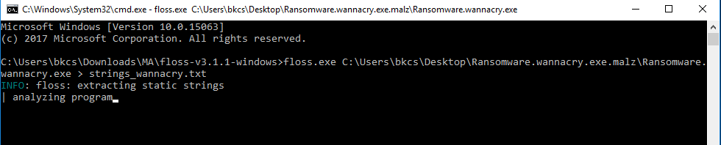
- You can find several suspicious APIs related to the Internet connection and CryptoGenRandom, and so on. It seems that this executable will connect to Internet using an URL.
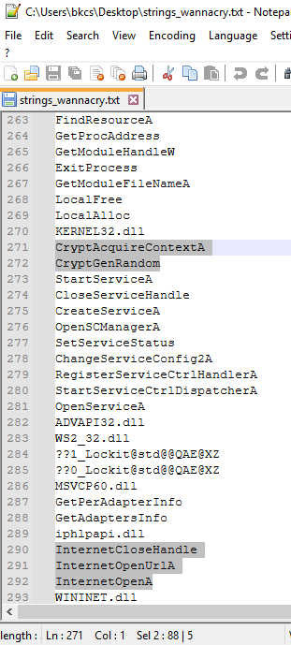
- When we search for “http”, we can find out these strings:
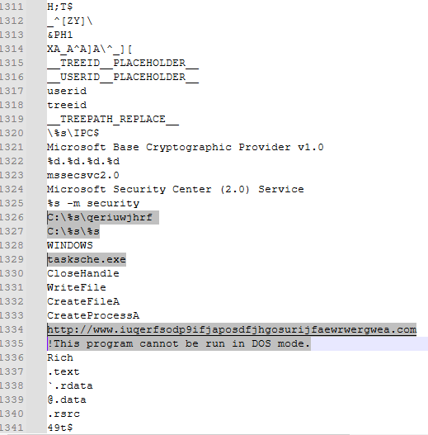
There is an URL, several directories, and an executable. We can also see this string “This program cannot be run in DOS mode”. It means that there are another executables embedded in this executable.
- We can see strings related to permission of files, password “WNcry@2o17”, an API related to Mutex. We can see windows binary like ‘icals’ and the command ‘attrib +h .’ suggests that it has some hidden directory somewhere.
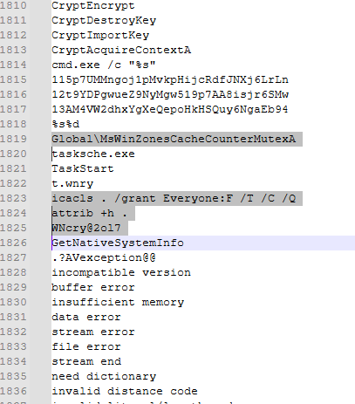
- We can also see some strings like this, maybe it can be a hash value or bitcoin address. When you check the addresses on blockchain.com, you can see that these are 3 bitcoin addresses.
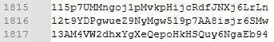
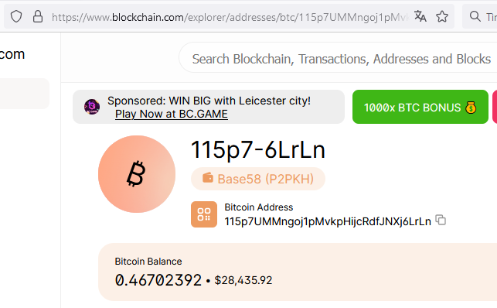
- Loading the binary to PE Studio to find additional information.
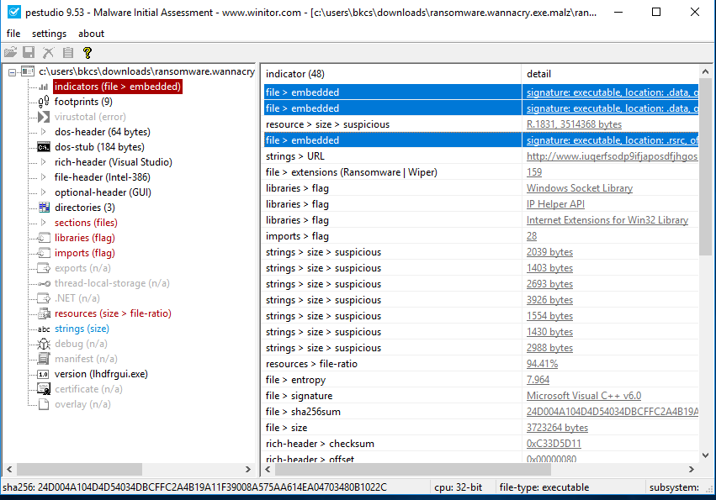
We start from “indicators”. It seems that there are three other packed executables inside this binary. We can see the hash information of this binary, type of APIs used. An interesting point is that PE studio is identifying file extensions like a Ransomware | wiper, it likely sees the .wrncy extension that is added to each of the files after they are encrypted.
- Now let go down and see the “libraries and imports”. With libraries, we can anticipate that there are some kind of socket usage and some kinds of internet usage as well.
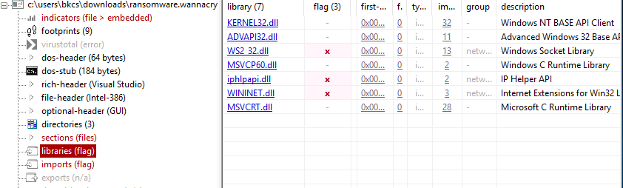
- Go ahead and check the imports. We need to check API dealing with cryptography. We anticipate that this is a ransomware binary, it makes sense that the APIs that are imported into the binary are going to deal with cryptography.
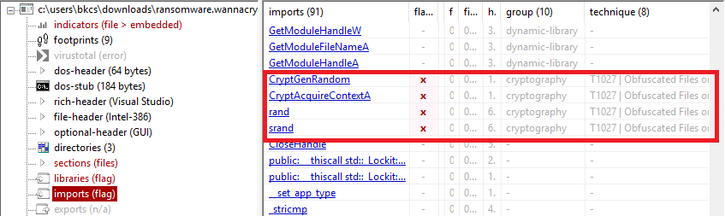
- We are anticipating that the binary maybe opening ports and maybe attempting remote connections to different ports. This allows to send and receive data and C&C commands.
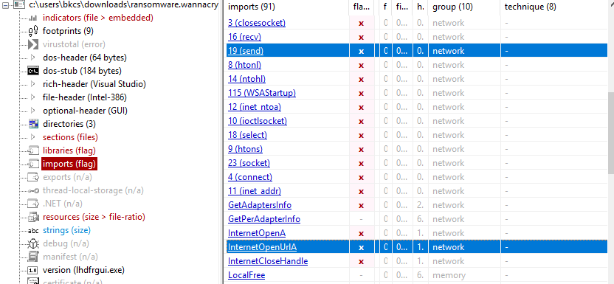
- We may be able to anticipate that there are some kinds of service creation with this binary.
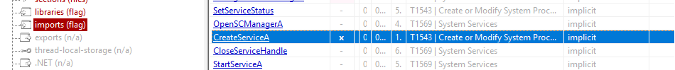
- Checking the difference between the raw and virtual size, we can say that there is a significant difference. We can conclude that this is a packed exe file and does have hidden payloads inside it.
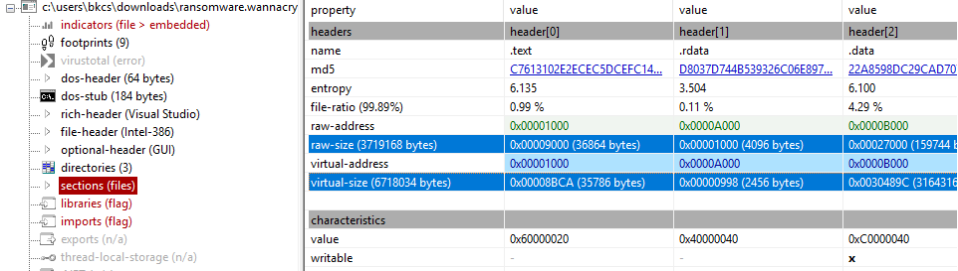
- Using IDA to check the flow of this binary.
When loading the binary into IDA, we stop at 0x00408140 in WinMain. Change from text to graph mode, so we can see as below:
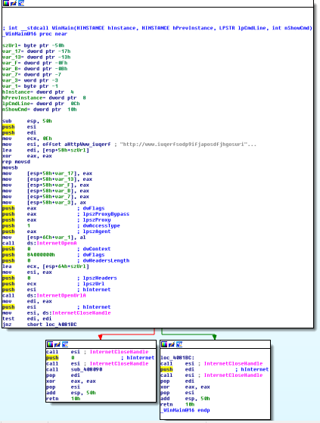
- This binary will push the URL “http://www.iuqerfsodp9ifjapos...” to esi and then call 2 APIs: InternetOpenA and InternetOpenUrlA. Depending on the output of InternetOpenUrlA API, binary will jump to the left or right branch.
- The output of InternetOpenUrlA is put to eax, then move eax to edi. After that, it checks the value of edi. If it is 1, it will jump to the right branch which call to InternetCloseHandle to close two connection (InternetOpenA and InternetOpenUrlA). Otherwise, if it is 0, the binary jump to the left branch. I will close two connections and call to another function sub_408090.
- Inside function sub_408090, we can see the flow as below. It will call to GetModuleFileNameA, OpenSCManagerA, SopenServiceA, StartServiceCtrlDispatcherA and so on. You can see the pseudocode by pressing F5.

Question 1: What is the purpose of these APIs? What is the purpose of sub_408090?
The APIs (GetModuleFileNameA, OpenSCManagerA, OpenServiceA, StartServiceCtrlDispatcherA) are used to interact with Windows services.
The purpose of sub_408090 is to install and start WannaCry as a Windows service, ensuring persistence and allowing the malware to run with higher privileges.

After this function, this binary will unpack the rest of the resources in the binary
and it will kick off the encryption routine.
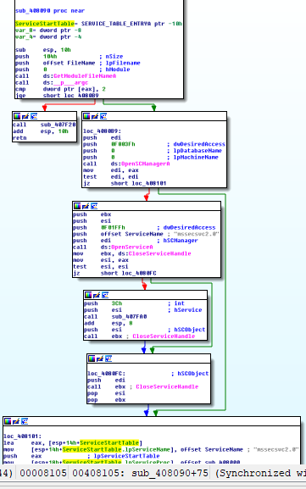
If you cannot guest the functionality of sub_408090, you can execute it in OllyDbg to identify its functionalities.
  - Dynamic Analysis
- EXE file: https://github.com/ytisf/theZoo/tree/master/malware/Binaries/Ransomware.WannaCry
- Load this binary to IDA and check strings (Shift+F12) and APIs (in Imports Window). Then, we find out a string “Global\MsWinZonesCacheCounterMutexA”. When we check the API used by malware, we also see an API related to Mutex “”
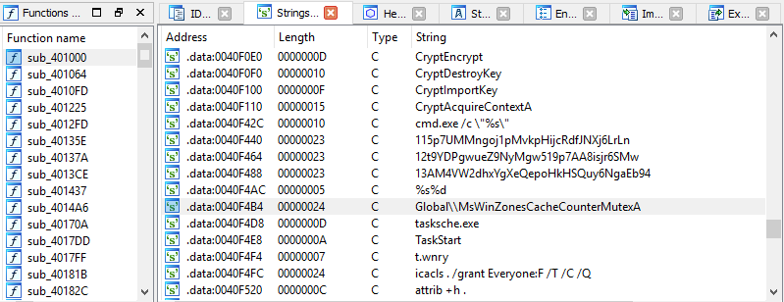
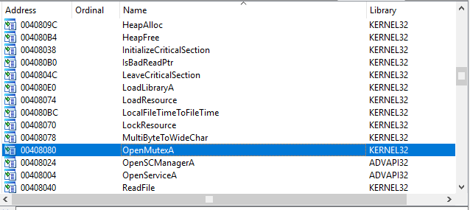
Now we load this binary to Ollydbg and start to execute it to identify its behaviors. You can search for “OpenMutexA” 🡪 Find references 🡪 Follow in Disassembler. Then, you can see as follows:
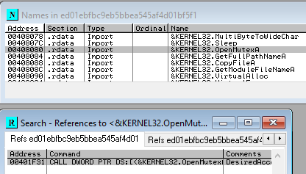
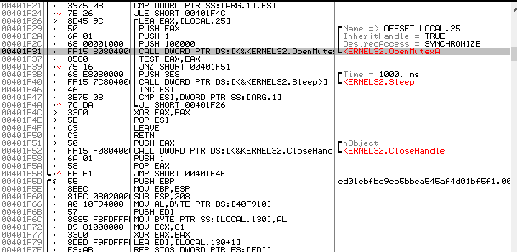
Question 2: What is the purpose of these commands with OpenMutexA? You can execute to easily find out.

OpenMutexA is used to check whether a specific mutex already exists.
If the mutex exists, the malware assumes the system is already infected and terminates execution.
This prevents multiple instances of WannaCry from running on the same system.

- Like other variants of Wannacry, this binary embeds another executable inside, so it needs to extract these executables during execution. This binary uses “WNcry@2o17” as a hardcoded password to extract these components.
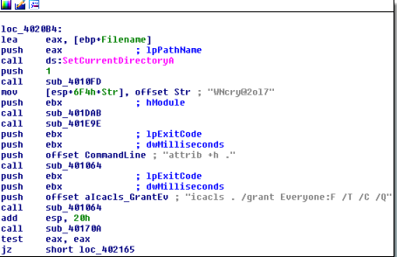
The extraction is performed inside function sub_401DAB. Let’s go ahead and see around this function. The following list of APIs will be called by this binary:
- FindResouce
- LoadResource
- LockResouce
- SizeofResource
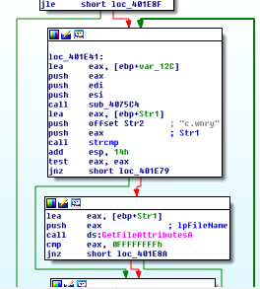
Question 3: What is the purpose of these four APIs? Explain each of them.

- FindResource: Locates an embedded resource inside the executable
- LoadResource: Loads the resource into memory
- LockResource: Retrieves a pointer to the resource data
- SizeofResource: Gets the size of the resource
These APIs are used to extract embedded files from the malware binary.

After calling these APIs, this subroutine uses XOR operation to decode loaded resources. When this process is complete, the files are extracted one-by-one via a loop. The following figure shows an example of extracting a file:
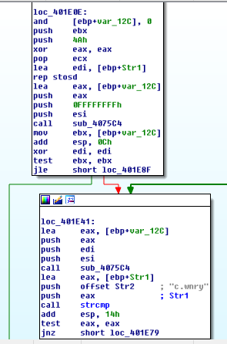
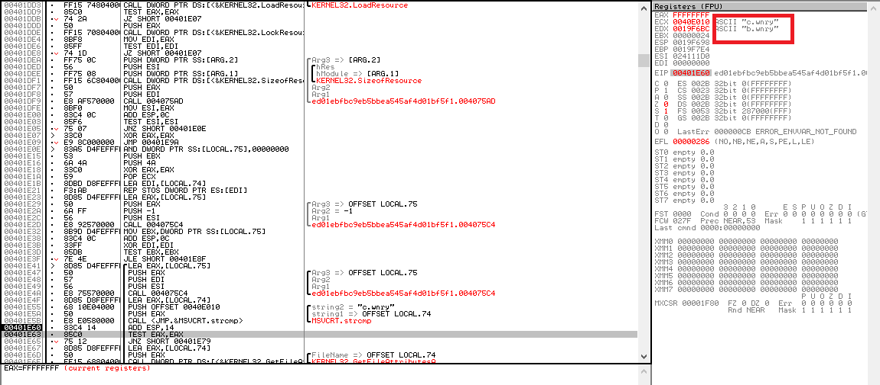
You can see the extraction process is repeated 35 times.
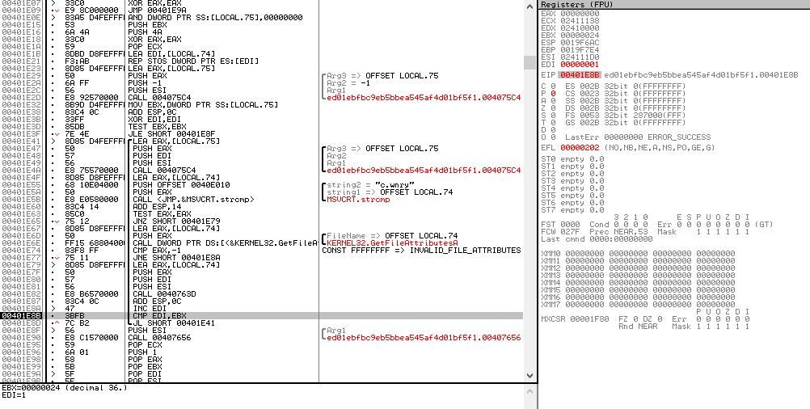
Question 4: What is the name and content of the first extracted file? What is the list of extracted files?
- The first extracted file is @WanaDecryptor@.exe, which displays the ransom note and payment instructions.
- The extracted files include multiple .wnry files, DLLs, executables, text files, and configuration files required for encryption, Tor communication, and ransom display.

Question 5: Are there any executables and what are they? What are the contents of text files (using online binary file viewer)?
- @WanaDecryptor@.exe
- taskdl.exe
- taskse.exe

- After sub_401DAB is sub_401E9E function. Let’s see it in detail.
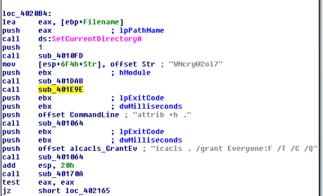
You can see 3 strings here:
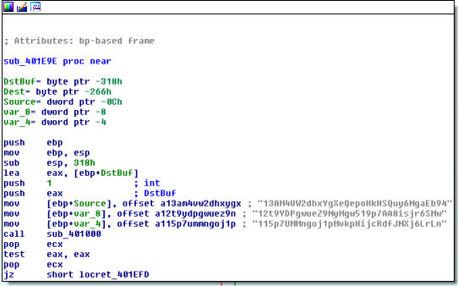
It can be hash value or something related to ransomware (bitcoin address). When you check the addresses on blockchain.com, you can see that these are 3 bitcoin addresses. After the files are extracted, the binary will grab 3 hardcoded Bitcoin addresses.
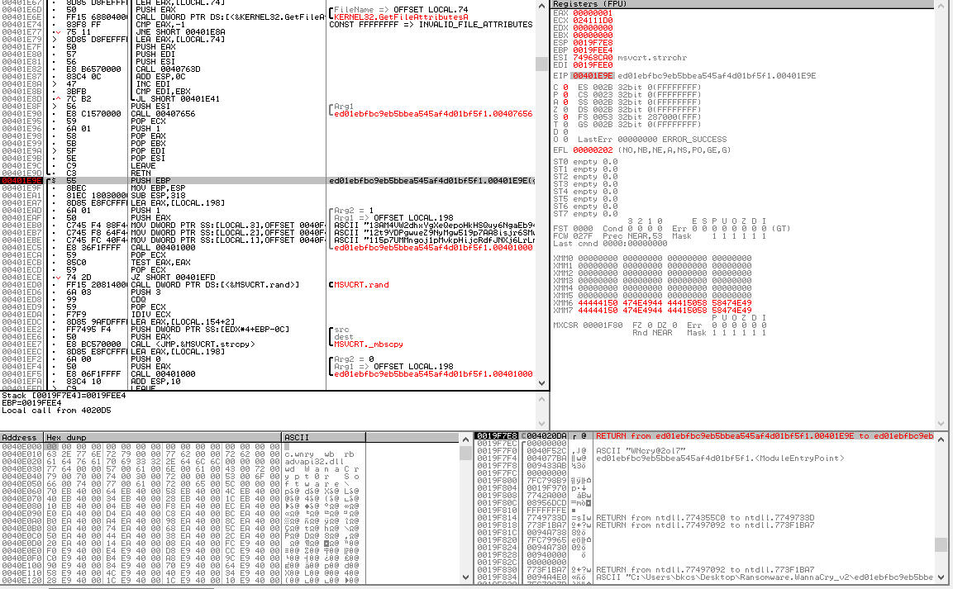
- Then, the binary will call to sub_401000 to read the content of c.wnry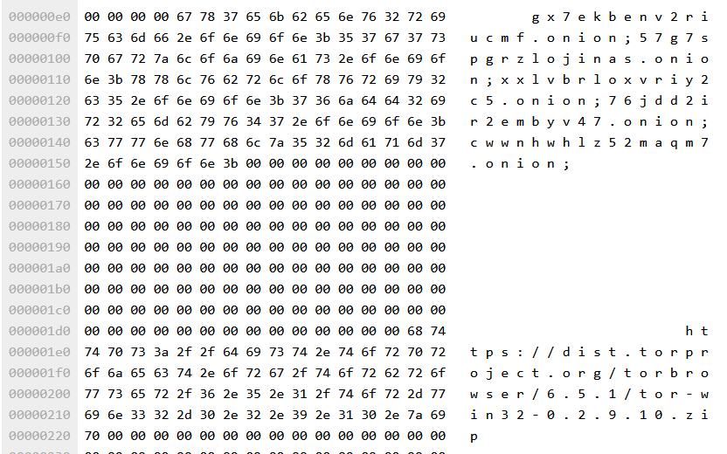
This file contains a full URL for downloading a Window Zip file for a Tor client.
- The next step is to change the attribute and permissions of files in the same folder and subfolder. It will implement two hardcoded strings:
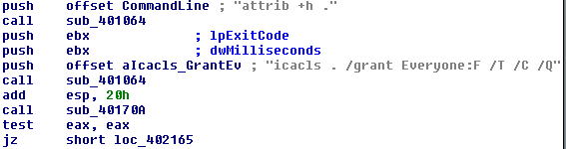
Once the strings are put in the stack, the binary file will call to sub_401064 for running each file. The malware will run these two commands to hide all additional malware components from the users.
- Next, the malware call to sub_40170A which is responsible for calling LoadLibrary to load kernel32.dll, and then following Window API functions using GetProcAddress. These API are used to create, read and delete files.
- In this step, malware will read the content of t.wnry file to get an AES key will be used to encrypt the files via enumeration process. This is executed in sub_4014A6. From this point, the malware lists all files on the system and encrypts each file. The extension is renamed to .wnry. At the end of the process, the wallpaper is changed.
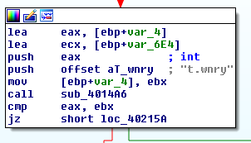
Here is the content of t.wnry:
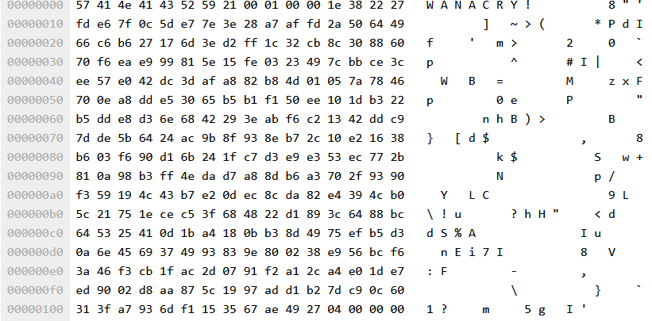
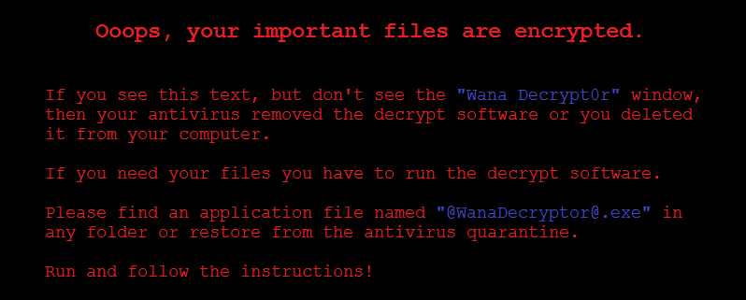
- Finally, malware will execute @WanaDecryptor@.exe (a renamed version of u.wnry) on the infected system.
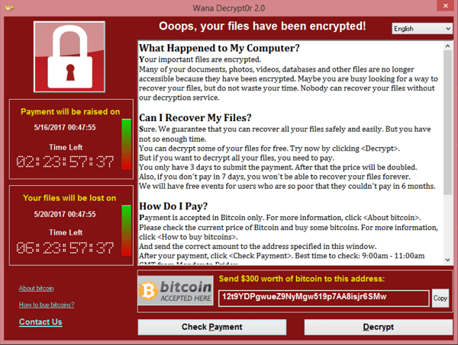
- Check the registry:
Question 6: Are there some things added to the registry (e.g., \SOFTWARE\, etc.)?
It modifies registry keys under HKLM\SOFTWARE to:
- Achieve persistence
- Configure service execution
- Store malware-related configuration data
Question 7: Please summarize the characteristics of Wanacry2.0
WannaCry 2.0 is a wormable ransomware that:
- Uses SMB vulnerability (EternalBlue) for self-propagation
- Implements a kill-switch domain
- Encrypts files and appends .wnry
- Uses AES + RSA encryption
- Displays a ransom note and demands Bitcoin payment
- Installs itself as a Windows service

Question 8: Explain the encryption algorithm of Wannacry and write a program to decrypt the encrypted files which the malware encrypted (optional).

